* Laugen
  + Reversing evolutionary changes > demographic changes
  + FIE changes
    - should not be ignored because they result in
      * Decreased yield
      * Decreas ed genetic diversity
      * Impaired recovery
    - Matsumura, S., Arlinghaus, R. and Dieckmann, U. (2011) Assessing evolutionary consequences of size-selective recreational ﬁshing on multiple life-history traits, with an application to northern pike (Esox lucius). Evolutionary Ecology 25, 711 – 735.
  + Ignoring FIE
    - Biased target and limit reference points
  + Dome shaped selex curve
    - Boukal, D.S., Dunlop, E.S., Heino, M. and Dieckmann, U. (2008) Fisheries-induced evolution of body size and other life history traits: the impact of gear selectivity. ICES CM2008/F:07.
    - Kuparinen, A., Kuikka, S. and Merila¨, J. (2009) Estimating ﬁsheries-induced selection: traditional gear selectivity research meets ﬁsheries-induced evolution. Evolutionary Applications 2, 234 – 243.
    - Jørgensen, C., Ernande, B. and Fiksen, Ø. (2009) Size-selective ﬁshing gear and life history evolution in the Northeast Arctic cod. Evolutionary Applications 2, 356 – 370.
    - Mollet, F.M., Poos, J.J., Dieckmann, U. and Rijnsdorp, A.D. (2010) Evolutionary impact assessment of commercial ﬁsheries: a case study of North Sea ﬂatﬁsh ﬁsheries management. In: Evolutionary effects of ﬁshing and implications for sustainable management: a case study of North Sea plaice and sole. PhD thesis, Wageningen University, The Netherlands, pp. 161 – 179.
    - Evolutionary stable yield can be obtained under higher F than sigmodial (Jorgensen and mollet)
* Vaughan 2002:
  + Reducing max sizes offers biggest improvements in the SPR without the risk of recoupment due to fish growth (red drum)
* Barnett 2017
  + Widespread age truncation
* O’Farrell 2006
  + Calculate maternal age effect (Za) for black rockfish
  + “Truncation of the age distribution by a fishery greatly reduces FLLP relative to FLEP when the distribution of egg production with the result being that conventional management can misrepresent declines in reproductive potential.”
  + Murawski 2001 cod citation
* Stige 2017
  + “high mean age and size in spawning stock of Barents Sea cod is positively associated with high abundance and wide spatiotemporal distribution of cod eggs”….no support for the hypothesis that a wide egg distribution leads to higher recruitment or weaker recruitment-temperature correlation”
  + Various studies conclude a range of importance of age truncation on recruitment.
  + Is the link between age and size distribution of spawning stock and recruitment supported by observation of realized egg distribution?
  + Egg abundance is best explained as a function of SSB, liver condition index and mean weight in the spawning stock F2A
* Tiainen
  + Experimental HSL and MLL in 4 lakes, decline of biomass and especially of largest fish in MLL lakes
  + HSL stronger impact on persevering old fish than population density…*in this time frame, over a longer period of time the population density impact could be more important*
* Jorgensen2009
  + Sharpe and Hendry 2009
  + Hamley 1975- gill net dome shaped curve also longlines (cod, Huse 2000)
  + Dome sharped curve better from sustainability perspective Law and Rowell 1993, Law 2007 (see also Huse 2000; Hilborn and Minte-Vera 2008)
  + Gear regulation as a tool to manage evolutionary trait changes generated by fishing practices…”What would a desirable harvesting regime look like from the perspective of an evolutionarily concerned fisheries manager?”
  + Aims:
    - Harvesting practices that lead to little evolutionary changes relative to pre-harvesting structure (Hutchings 2009)
    - Gear type is robust to excess harvesting …to control harvest rate
  + Model:
    - Maximize lifetime expected fecundity
      * P: age, length, enerty storage, env. Factors
      * 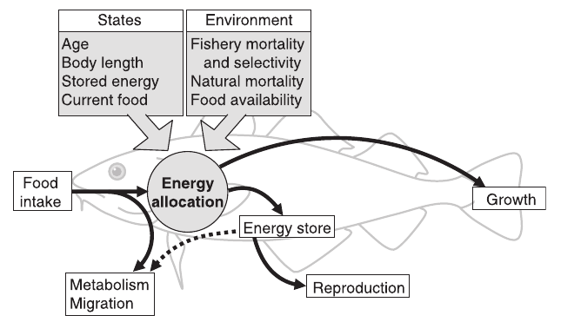
  + Two fishing grounds
    - Feeding grounds
      * Immature fish all year round
      * Mature fish 7/12 of year
      * High mortality here favors early maturing fish which manage to reproduce before harvest
    - Spawning grounds
      * Mature fish only
      * High mortality here favors fish that are large when they risk the mortality to reproduce and thus selects for late maturation **interesting idea, need to read more about this Law and Grey 1989**
  + Selex curves
  + 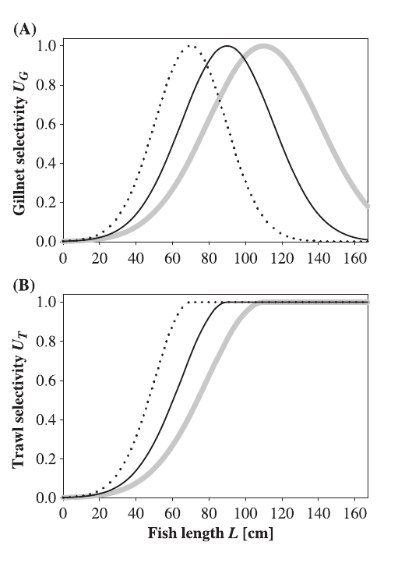TEP model

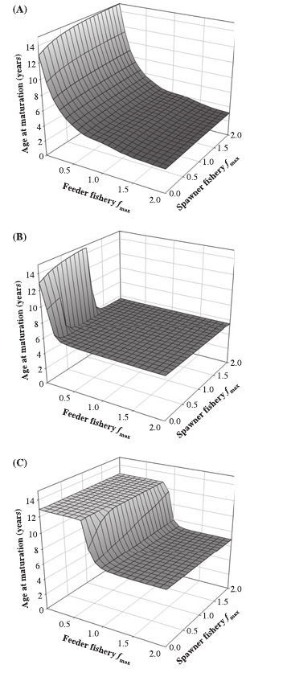

* + Fish on spawning grounds with a dome shaped selex curve allows a much higher Fmax than with a sigmoidal curve….the FMax decreases, however, with increasing Fmax on the feeder fishery…this impacts both the evolution of life history traits and fisheries yield
  + Marteinsdottir and Thorarinsson 1998 a diverse age structure leads to enhanced recruitment in Icelandic cod
  + **Fishing on spawning grounds, removing only mature fish, will increase age at maturation (figure above, still don’t get this)**
* Brunel 2013- big picture…emphasis on selection not age strcuture
  + Is a well-balanced age structure indicative of a healthier stock?
  + Can managers exert a control on age structure, independently from the regulation of stock abundance?
  + Results
    - Age structure is highly dependent on selection pattern
    - Selection pattern determines the ability of fish stocks to withstand (and recover) from perturbations
    - Selection pattern determines the output of the fishery
  + Age truncation citations Berkely 2004b, Otterson 2008 Hidalgo 2011
  + Natural varaiblity confounds and competes with demographic effects of fishing
  + Balanced harvesting (Garcia 2012, law 2012) in which F is distributed across species size classes
  + How age truncation impacts
    - 1. Balanced age structure
      * buffers environmental flux (planque 2010)
      * buffers recruitment variability
      * truncated structure are more sensitive (hidalgo 2011, rouyer 2011)
    - 2. larger old fish are important independent of biomass
    - 3. Contracted spawning season and distribution
  + Truncation should reduce stock capacity
    - **Cohort resonance effect bjornstad 2004, hidalgo 2011**
  + Incorporated maternal effect (egg hatching rate) for cod
  + 5 selection patterns
    - Flat
    - Current
    - Knife edge
    - Protect old (slot)
    - Productivity
  + Assessment
    - PL>Lmax proportion of fish larger than mean size at maturation
  + Results
    - Fishing mortality largest influence between prestein and exploited states
    - Selection pattern also influential on some parameters (PL>Lmax and sp.mean.age)
    - Dome shape curve caused lowest variability while knife edge highest
  + Discussion
    - No relationship between age structure and health for an populations
    - But slower responsiveness to fishing pressure in pops with old fish
    - Selex pattern > age structure
      * Mechanical effect of applying a specific selection pattern rather than real influence of age structure itself
* Thoughts
  + Combining slot and bag savings…should it be based (somewhat) on the proportion of fish at length? Ie if slot is very high (55-60 cm) then there are not going to be many 4 fish trips, so is our approach an oversimplification?
  + How widespread is the use of inappropriate age plus groups in stock asseessments
  + Sorting grids kick out the small fish…perhaps this is wrong and should just be harvesting “fish”…but economically that is not a viable option, or can it be?
  + Size dependence of release mortality in Tautog….need to read the work on release mortality
  + Can we use Fmsy, Fpa or Flim as indicators in our analysis?